**ESSAY WRITING- KEY WORDS**

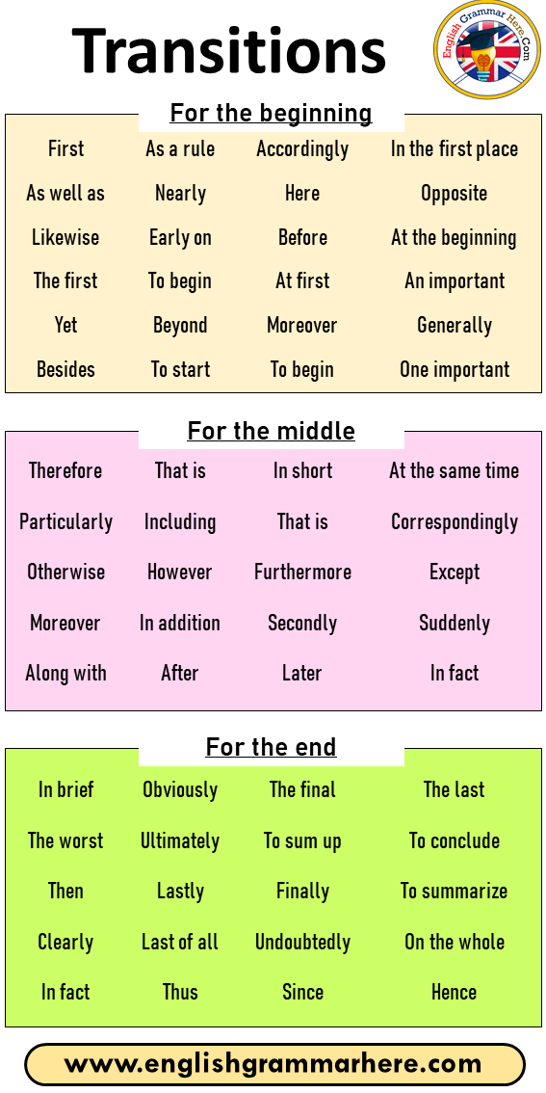



https://englishgrammarhere.com/